16. Perform Edge Detection Using Canny Method
Aim
To perform edge detection on an image using the Canny Edge Detection algorithm in Python with OpenCV.
Procedure
- Import the OpenCV library.
- Read the input image.
- Convert the image to grayscale.
- Apply the Canny edge detection algorithm with suitable threshold values.
- Display the original image and the detected edges.
- Close all windows after a key is pressed.
Python Code
import cv2

# Read the image
image = cv2.imread("image.jpg")

# Convert to grayscale
gray = cv2.cvtColor(image, cv2.COLOR_BGR2GRAY)

# Apply Canny Edge Detection
edges = cv2.Canny(gray, 100, 200)

# Display images
cv2.imshow("Original Image", image)
cv2.imshow("Canny Edge Detection", edges)

# Wait until a key is pressed
cv2.waitKey(0)
cv2.destroyAllWindows()
Output
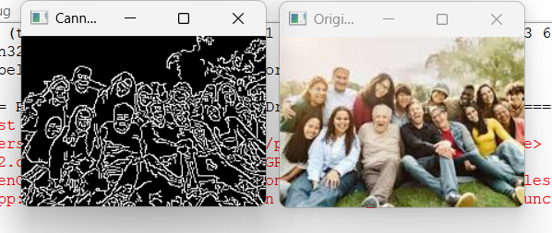

Result
The edges of the given image were successfully detected using the Canny Edge Detection method in Python with OpenCV.

